Software Engineering Stage 6
(Year 12) – Software Engineering Systems Report Template


Contents
1. Identifying and defining 2
1.1. Define and analyse problem requirements 2
1.2. Tools to develop ideas and generate solutions 3
2. Research and planning 4
2.1. Project management 4
2.2. Quality assurance 5
2.3. Systems modelling 6
3. Producing and implementing 12
4. Testing and evaluating 13
4.1. Evaluation of code 13
4.2. Evaluation of solution 14
Progress Diary 18

1. Identifying and defining

1.1. Define and analyse problem requirements
Problem context
Students analyse the problem by describing each of its individual components and explaining how each of these components contribute to the problem needing resolution.
The first component that needs resolving is real money in gambling, as it has legal issues especially on online platforms. This app will stop the problem by making gambling use fake money so it’s purely fun only and legal.

Needs and opportunities
Students describe the needs of the new system to be built based on the problem context and using the table given below.
Need | Description
1. Customers(add, delete, edit) | This is needed because the system must be able to manage customer information efficiently. Being able to add, delete, and edit customers allows records to stay accurate and up to date, which helps with tracking user activity and maintaining organised data.
2. Functioning game | This is needed because the game is the core feature of the system. It must run smoothly and reliably so users can interact with it properly, ensuring a good user experience and allowing all other features, such as tracking wins or losses, to work correctly.
3. Database (Wins, total earned, total lost(private), Name (private)) | - This is needed because the database stores important game and user information, such as wins and virtual money totals, allowing the system to track player progress and performance over time. Keeping certain details like total losses and names private helps protect user information while still allowing the game to function properly.

Boundaries
Students analyse any limitations or boundaries in which this new system will need to operate. Boundaries can include but are not limited to: hardware, operating systems, security concerns etc.
The hardware that will limit us is my slow laptop

1.2. Tools to develop ideas and generate solutions
Identification of appropriate software development tools
Students identify appropriate tools for each of the given software development situations. They then explain how each tool is applicable or not to the current project.
Situation | Tool applicability | Reason
Brainstorming, mind-mapping and storyboards
Data dictionaries
Algorithm design
Code generation
Testing and debugging
Installation
Maintenance

Implementation method
Students explain the applicability of the implementation method for the current project. These are normally: direct, phased, parallel and pilot.
Direct – do it
Phased – yes
Parallel – 2 task at once (multitasking)
Pilot – in small precise sections

2. Research and planning

2.1. Project management
Software development approach
Students explain the software development approach most applicable for this current project. These are normally: Waterfall, Agile and WAgile.
Scheduling and task allocation
Students develop a Gantt Chart that details the tasks required to be completed, person or people assigned to each task, timeline that does not exceed the project due date, resources required. In addition, students identify any collaborative tools used. For example Repl.it, GitHub and so on.

2.2. Quality assurance
Quality criteria
Students explain quality criteria based upon the needs from Section 1.1. These quality criteria should contain qualities, characteristics or components that need to be included or visible – based on Section 1.1. – by the end of the current project.
Quality criteria | Explanation

Compliance and legislative requirements
Students explain compliance and legislative requirements their projects need to meet and how they plan to mitigate them where possible. For example, projects that deal with sensitive personal data being publicly available may fall under the Australian NSW Privacy and Personal Information Act (1998) and/or Federal Privacy Act (1988). Alternatively, international standards on information security management such as ISO/IEC 27001 may also be applicable.
Compliance or legislative issue | Methods for mitigation

2.3. Systems modelling
Students are to develop the given tables and diagrams. Students should consult the Software Engineering Course Specifications guide should they require further detail, exemplars or information. Each subsection below should be completed with Section 1.1. in mind.
Data dictionaries and data types
Students take the needs identified in Section 1.1. of this Systems Report. For each need, students identify the variables required, data types, format for display, and so on.
Need
1.
Variable | Data type | Format for display | Size in bytes | Size for display | Description | Example | Validation
Id | Integer |  | 4 |  | Auto-incremented primary key uniquely identifying each user account. | 1,2,3,4,5,6,7…
Username | String |  | < 51 |  | User chosen display name used as the login identifier. Must be unique across all accounts. | Coolboy
Password hashed | String |  | 60-72 |  | Werkzeug bcrypt hash of the user's password | "pbkdf2:sha256:…"
Wallet | Integer |  | 8 |  | Money balance in game | $1000000
Created_at | Data/Time |  | 19 |  | Records when account created utc timestamp tingy | 2026-05-29 9pm

Need
2.
Variable | Data type | Format for display | Size in bytes | Size for display | Description | Example | Validation

Need
3.
Variable | Data type | Format for display | Size in bytes | Size for display | Description | Example | Validation

Data flow diagrams
Students develop data flow diagrams (DFDs) at Level 0 and Level 1. These diagrams should explicitly include the variables from the data dictionaries previously identified as well as the needs identified in Section 1.1.
Level 0

Level 1

Structure charts
Students develop structure charts demonstrating how the procedures, modules or components of the final solution are interconnected.

Class diagrams
Students develop class diagrams demonstrating how each class is related to the other.

Storyboards
Students develop storyboards, visually representing the software solutions they will build.

Decision trees
Students develop decision trees to visually outline the logic flow and chain of decisions or selections the final solution will need.

Algorithm design
Students develop algorithms using methods such as pseudocode or flowcharts to solve the problem and meet the needs from Section 1.1. These algorithms should explicitly include the variables from the data dictionaries created in the previous section.

3. Producing and implementing
Solution to software problem
Students are to include screen shots of their final developed solution here (if the solution uses a GUI, include annotated screenshots as well as code (commented)). Each screenshot should include a caption that explains how it links to the:
- Needs identified in Section 1.1.
- Components of Section 2.3. such as the storyboards, data dictionaries and so on.

Version control
Students describe what version control system or protocol was implemented.

4. Testing and evaluating

4.1. Evaluation of code
Methodology to test and evaluate code
Students explain the methodologies used to test and evaluate code. Methodologies include:
- Unit, subsystem and system testing
- Black, white and grey box testing
- Quality assurance.

Code optimisation
Students explain the methodologies used to optimise code so that it runs faster and more efficiently. Methodologies include:
- Dead code elimination
- Code movement
- Strength reduction
- Common sub-expression elimination
- Compile time evaluation – constant folding and constant propagation.

4.2. Evaluation of solution
Analysis of feedback
Students analyse feedback given to them on the new system they have just created. This feedback can be in the form of an interview, survey, focus group, observation or any other applicable method. Students should also include overall positive, negative or neutral sentiments towards the new system in their response.

Testing methods
Students identify the method or methods of testing used in this current project. For each they use, students are to explain how and why it was used.
Method | Applicability | Reasoning
Functional testing
Acceptance testing
Live data
Simulated data
Beta testing
Volume testing

Test data tables
Students identify variables which were used for either path and/or boundary testing. Students develop these test data tables based on their algorithms versus their real code. Students then state the reason for including said variables.
Variable | Maximum | Minimum | Default Value | Expected Output | Actual Output | Reason for Inclusion
Boundary testing

Path testing

Analysis of solution against quality success criteria
Students are to take each quality success criteria from Section 2.2 and place it here. For each quality criteria, analyse the components of the solution that met or did not meet each quality criteria. Give reasons why each success criteria were or were not met.
Quality criteria | Met? | Analysis

Process Diary
24/04/2026
Made file directory
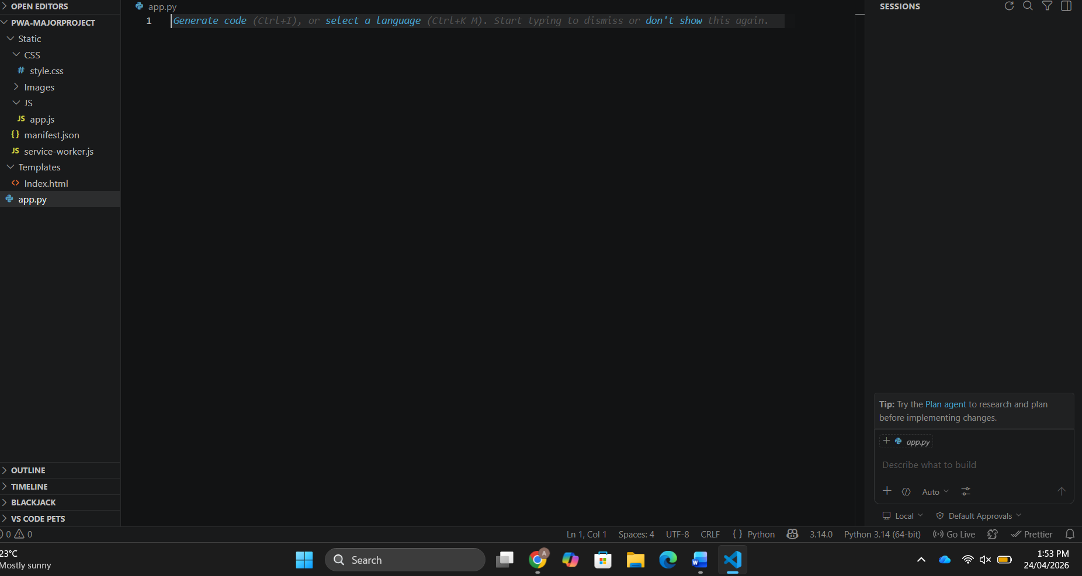
Worked on must haves and identifying the problem as well as how I am resolving.
